Remote3c User Manual

V 1.0

Catalog
1. Scope of Service 3
1.1. About Remote3c 3
1.2. About this Manual 4
2. Installation 5
2.1. Remote3c software Downloads 5
2.1.1. Download the software from PC 5
2.1.2. Download the software from ios device 5
2.2. Installing Remote3c 6
2.3. Server Install 6
3. Basics 7
3.1. Connection 7
3.2. Main Interface 7
3.3. Remote desktop 8
3.4. keyboard/mouse 11
3.5. IR Control 13
3.6. More Interface 14
4. Copyright 17
The software is owned by Jetcent technology Co., Ltd. 17

Scope of Service

About Remote3c
Remote3C, a remote control system, supports full PC/TV keyboard 、PC/TV mouse and TV IR; control a Windows desktop from an ios or Android device over a WiFi network; realize online collaboration plus resources sharing by simulating remote keyboard, mouse or IR to remote control (such as mobile control TV, mobile control computer, computer remote controlcomputer, etc.)
Features:
Remote Control: you can remote control computer and TV set through your mobile phone
Remote monitoring: Mobile phone and PC can monitor video captured by controlled computer
Remote Meeting / Demo: online presentations or collaboration
Remote desktop: share your desktop for authorized users
Remote mobile phone input method (only TV version)
Media sharing: You can share the device's media files to other devices for download or play
File upload: upload local file to server or other device
Remote mobile phone input method (only TV version)

More…
Video chat
Free sms text chat

About this Manual
This manual describes the use of Remote3c. Unless specified otherwise, the described functionality always refers to the version of Remote3c indicated in the title.
Mac OS is a registered trademark of Apple Inc. Linux is a registered trademark of Linux Foundation.
The terms "Microsoft" and "Windows" used here are registered trademarks of Microsoft Corporation in the United States and other countries. For simplification purposes, this manual refers to the operating systems Microsoft® Windows® Millennium Edition, Microsoft® Windows® 2000, Microsoft® Windows® XP, Microsoft® Windows® Vista and Microsoft® Windows® 7 simply as “Windows.”

Installation

Remote3c software Downloads

Download the software from PC
search with the “Remote3c” keyword on MAC App Store on MAC、linux or Windows system hosts ，find the application named by “Remote desktop & TV Remote”，the icon is below:


diagram 2-1
Tap the install，the Remote3c software will be downloaded and install to the host, then Synchronous to your ios device( itouch pod/ iphone/ipad) 。

Download the software from ios device
Search with the “Remote3c” keyword on MAC App Store on ios device, find the application named by “Remote desktop & TV Remote”, Press the button “ install”，the Remote3c software will be downloaded and install to your ios device

Installing Remote3c
After download to MAC or Windows on App Store, click the Synchronous button, you may Synchronous the remote3c software to ios device

Server Install
Visit our website: www.remote3c.com, click the download Tab, click the Remote3C_Server_en download, after download, install and run it, the window is below:
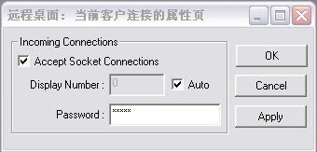
diagram 2-2
Set the Authentication password which connected between ios device and PC, the below is remote3c service manager window
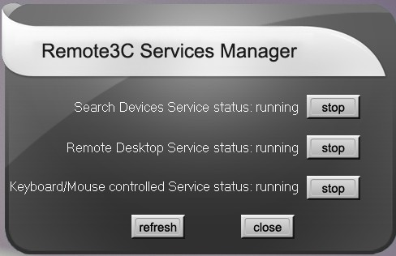
图 2-3

Basics
The current version supports connecting one PC and supports simplified Chinese and English language

Connection
The program will automatically save the last successful connection IP address, and automatically re-connect next time, it will prompt information if the connection is successful

Main Interface
Main Interface include: Remote Desktop, keyboard/mouse, IR Control, device Scanning, set the IP address, about etc.
The main Interface as below:
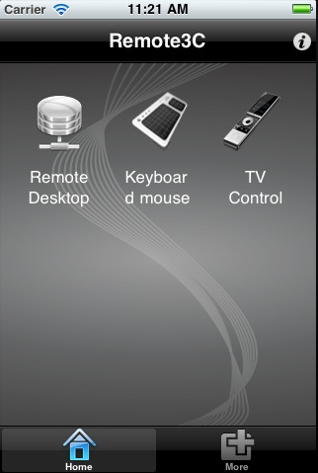
diagram 3-4

Remote desktop
Tap the “Remote Desktop” in main interface, pop the dialog as below:
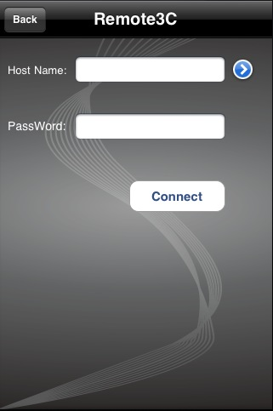
diagram 3-5
Input IP Address or Host Name in“Host Name”edit box or tap the icon,select the IP address from IP address list, the IP Address will show in “Host Name” edit box，pop the window as below:
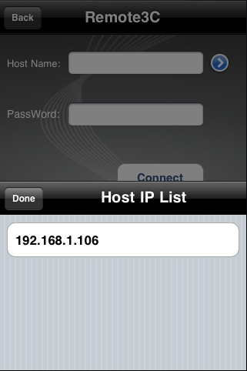
diagram 3-6
Input the password connected the PC in “Pass Word” edit box, the detail reference to section 2.3
Tap the “Connect” button, enter into Remote desktop interface, as below:
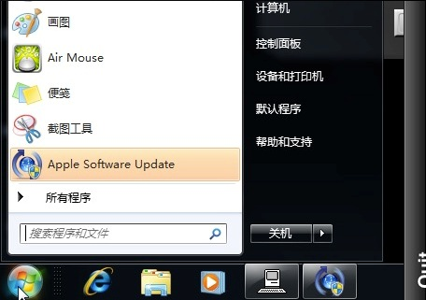
diagram 3-7
Remote desktop support the gestures such as move，scale, click , tap the "Quit" button on taskbar to exit the remote control and back to the main interface.

keyboard/mouse
Tap the "Keyboard mouse" in the main interface to enter into keyboard and mouse interface, when the handheld device screen vertically display the mouseinterface, one click or double click (right analog), sliding ,the interface as below:
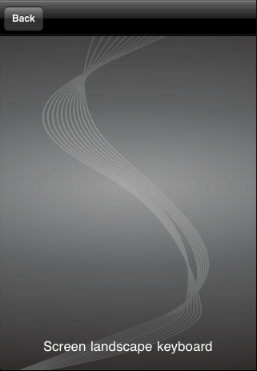
diagram 3-8
Landscape Screen show keyboard interface, support sending combination key, when you tap the "Comb" button, show as , Combination buttons function is opened, then enter combination key whose max value is four key, tap the button again, sending the combinations key, the keyboard interface as below:

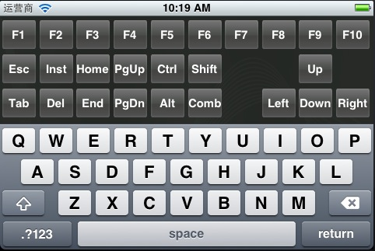
diagram 3-9

IR Control
The main interface tap "IR Control" to enter into the TV remote control interface, slide up and down, the interface as below:
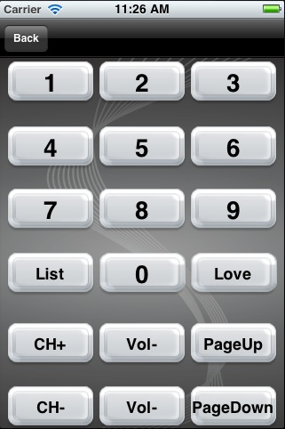
diagram 3-10
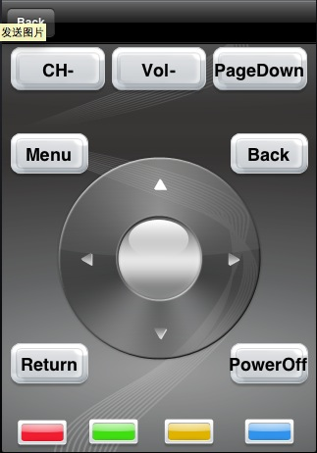
diagram 3-11

More Interface
Contains "Scan device" and "Set the IP address “
Tap "Scanning device" button on the " Scan device " interface to search device’s IP address from local network, the interface as below:
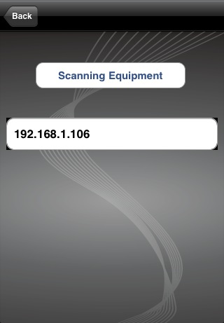
diagram 3-12
Select the one from IP address list, it prompt connected successful if the connection is success, or prompt re-search.
Topping input box on the "Setting" interface can be set to specify the connecting IP address. Tap the "Enter" key to perform connecting; the bottom area of the window will show your IP address, the interface as below:
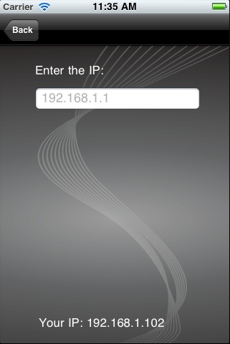
diagram 3-13

Copyright

The software is owned by Jetcent technology Co., Ltd.

